Early Years Curriculum Overview 2021 - 2022
 | Autumn Term 1  #WeAre  Lemington | Autumn Term 2  #WeWill  Remember | Spring Term 1  #WeAre  Global | Spring Term 2  #WeAre  Resilient | Summer Term 1  #WeAre  Ambitious | Summer Term 2  #WeAre  Collaborative
Intent
What we want our children to learn  We recognise that some of our children are on average, 4 months behind if they are in less deprived areas. Our curriculum has been developed to bridge that gap. | We want the children to learn about themselves, who they are as an individual, understand that not everyone is the same and to celebrate those differences.  We want children to learn about our school where their journey begins in education. | Our Nursery (now Reception) children love working outside. We want the children’s learning to focus on this and expand their current knowledge and understanding. We will focus on life cycles and the importance of trees. | We want our children to be exposed to the world around them beyond Lemington.  During 2020-2021, we have a focus week of travelling the world so we have developed on this to explorethe whole world and each continent. | Our children love building and making things in the creative area. We want to build upon this interest by linking to the importance of reusing and recycling. | We have taught space in the past and it has always been popular. Our Nursery (now Reception) children loved a story about aliens so we decided to use this love as a hook for their learning. | We recognise the importance of traditon tales and many of our children are not aware of them. The children prefer the newer tales such as the Gruffalo so to develop their love of reading and expose them to a broader range of tales, we will focus on the more traditonal stories.
Targeted Objectives | Nursery:Shows confidence and self-esteem through being more outgoing towards people, taking risks and trying out new things and new social situations and being able to express their needs and ask adults for help.  Reception: To talk about themselves, their family, school and Lemington. | Nursery:Comments and asks questions about aspects of their familiar world such as the place where they live or the natural world.  Reception: To understand the important processes and changes in the natural world around them, including the seasons and changing states of matter. | Nursery: Shows an interest in different occupations and ways of life indoors and outdoors.  Reception: To know similiarities and differences between the natural world around them and contrasting environments, drawing on their experiences and what has been read in class. | Nursery: Begin to understand the effect their behaviour can have on the environment  Reception: To share their creations, explaining the process they have used. | Nursery: Develops an understanding of using lines to enclose a space, and begins to use drawing to represent actions and objects based on imagination, observation and experience  Reception: Begin to show accuracy and care when drawing. | Nursery: Creates sounds, movements, drawings to accompany stories  Reception: To safely use and explore a variety of materials, tools and techniques, experiementing with colour, design, texture, form and function.
Implementation
Topics | All about me  What makes me a me? | Inside a tree  How does an acorn grow? | All Around the World  Why is the sea blue? | Rubbish and Recycling  What will a box be next? | Inside Spacce  How do you catch a star? | Traditional Tales  Which is your favourite?
Focus Book | 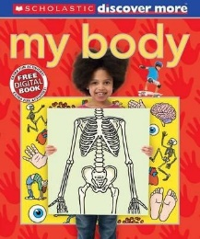 | 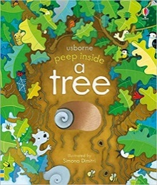 | 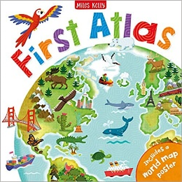 | 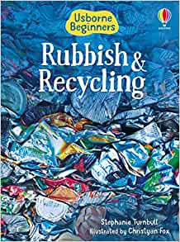 | 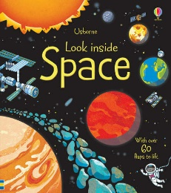 | 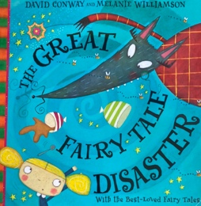
Books to guide learning  Week 1 | 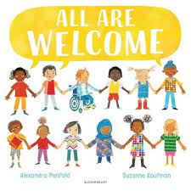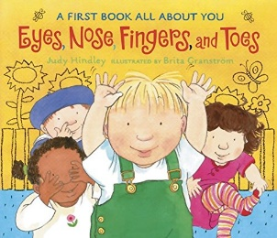 | 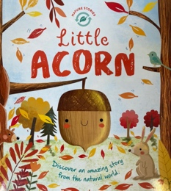 | 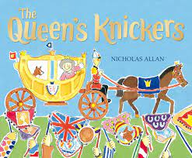 | 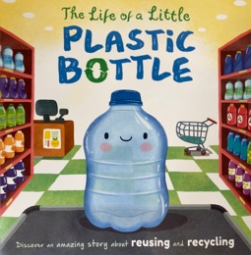 | 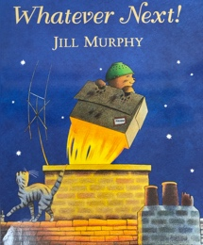 | 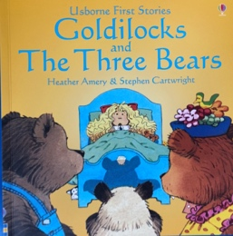
Week 2 | 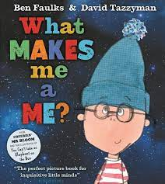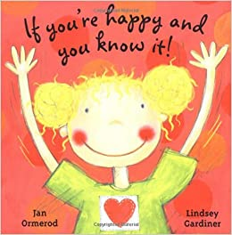 | 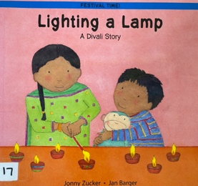 | 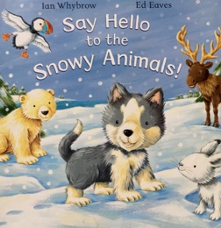 | 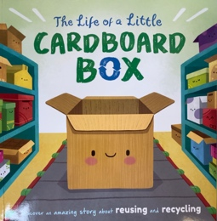 | 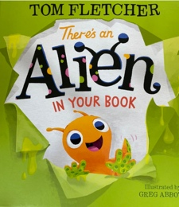 | 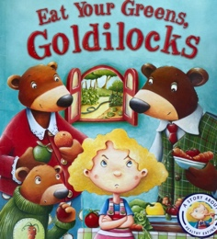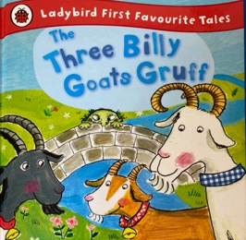
Week 3 | 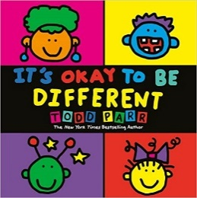 | 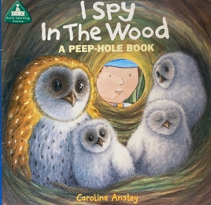 | 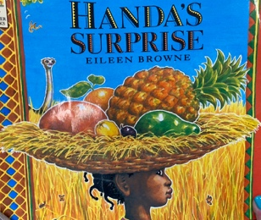 |  | 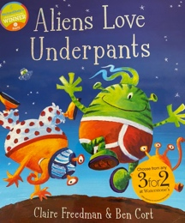 | 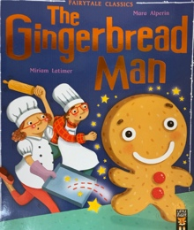
Week 4 | 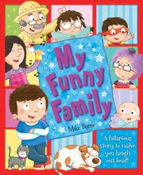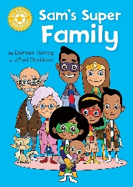 | 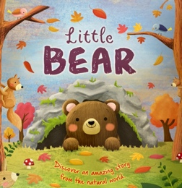 | 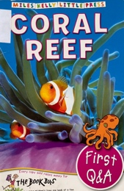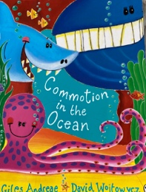 | 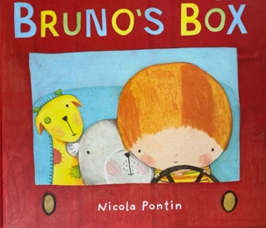  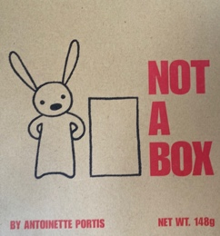 | 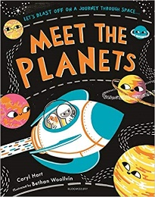 | 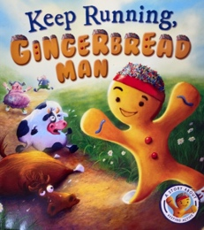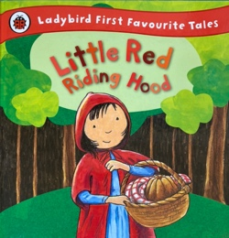
Week 5 | 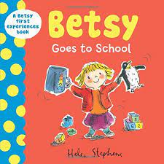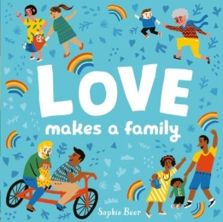 | 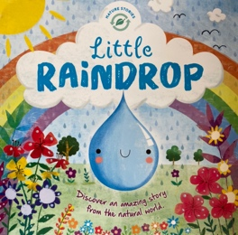 |  | 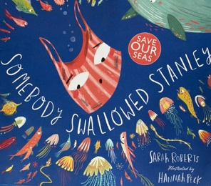 | 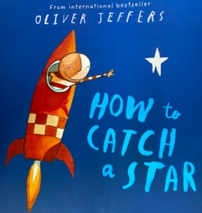 | 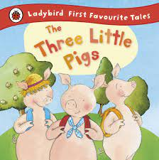
Week 6 | 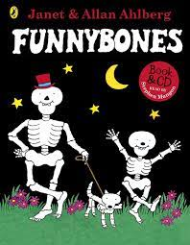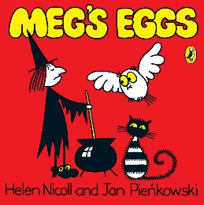 | 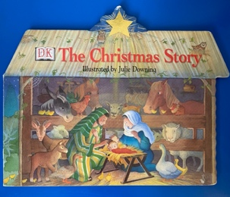 | Frankie and Bennie’s food menu | 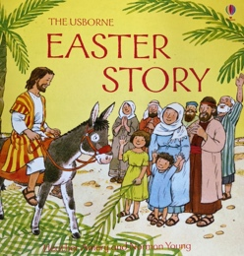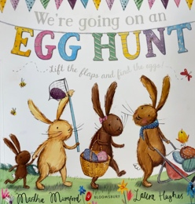 |  | 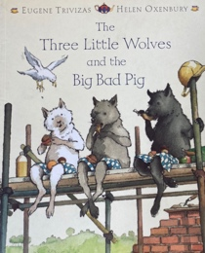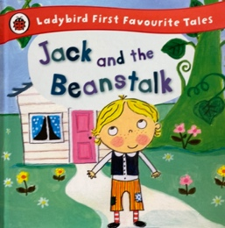
Week 7 |  | 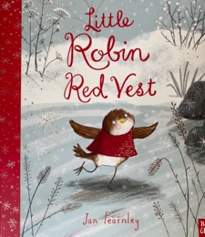
Tier 3 Vocabulary | Lemington,  Chef,  Relative,  Friendship. | Raindrop,  Acorn,  Tree trunk,  Hibernate,  Divali. | Reef,  Antarctica,  Arctic,  Cambodia,  Asia,  Europe,  America, | Recycle,  Reduce,  Reuse. | Spaceship,  Mercury,  Venus,  Earth,  Mars,  Jupiter,  Saturn,  Uranus,  Astronaut. | Harp,
Tier 2 Vocabulary | Family,  Friends,  School,  Mum,  Dad,  Sister,  Brother,  Gradnma,  Grandad,  Teacher,  Head teacher,  Cook. | Seed,  Rain,  Leaf,  Tree,  Winter,  Candle. | Ocean,  Ice,  Frozen,  Dance,  Names of arctic and reef animals. | Box,  Bottle,  Use again. | Rocket,  Moon,  Sun,  Star,  Alien,  Space man. | Sprint,  Wood cutter,  Healthy,  Golden,  Egg,  Wood,  Straw,  Brick,  Bake,  Gingerbread,  Stranger,  Porridge,
Suggested visitors/trips | Visit around Lemington:  -coffee shop,  -post office,  -church,  -Asda,  -Playgroup. | Visit the farm for Christmas to see Santa. | Blue Reef Aquarium | Recycling centre. | Centre for Life Planetarium | 7 stories.
Links to Computing | Draws on iPad.  Can lock and open iPad.  Able to move a mouse and select on a computer.  Follows simple directions by an adult during unplugged activities. |  | Able to select an app directed by an adult.  Able to type and use a mouse (select and drag) on a computer.  Able to give simple instructions during unplugged activities. |  | Able to programme on iPad game.  Attempts/able to log on to computer.  Able to give and follow two-part instructions from peers in unplugged activities.
Impact
Assessment | Our children will learn our rules and routines whilst settling into our classroom, Nursery children will be able to talk about themselves and peers, looking at similarities and differences.  Reception children will be able to talk about Lemington and our school, who works here and their roles. | Our children will be able to talk about how things grow. Nursery will be able to tlak about the world around them and what they can see.  Reception will be able to talk about the life cycles. | Our children will be able to talk about the world wider than Lemington.  Nursery will be able to describe the different places in the world.  Reception children will be able to compare the different locations around the world. | Our children will be able to talk about ways to look after Earth.  Nursery children will be able to recycle their rubbish.  Reception will understand reusing something to turn it into something new. | Our children will be able to talk about how to get into space.  Nursey children will be able to draw using the experiences they have gained.  Reception children will be able to draw with skills based on Space. | Our children will be able to retell the traditional tales.  Nursery will be able top use their actions to help them retel the story.  Reception will be able to use the Story Hat and retell a story. We will also be building props to link with the story to support their recall.
Rhymes taught during Rhyme Time (12:40pm daily) | One finger, one thumb,  Heads, shoulders, knees and toes,  Do you ears hang low? |  | Mary had a little lamb,  Little Bo-Peep,  Five Little Speckled Frogs. |  | Boom Diddy Gorilla,  Here is the Beehive,  Here we go round the Mulberry Bush.

