The selection and appointment of Parent Governors
on School Governing Bodies

Application form for prospective

Parent Governors

Please complete in capital letters

Surname

First name

Title

Address

Postcode

Email

Telephone (H)

Telephone (M)

Telephone (W)

- Do you have time to attend meetings and visit schools, Yes No

including during school hours?

- Are you prepared to undertake appropriate governor Yes No
training?

For questions 3 and 4 below, please answer the questions as fully as you can.
(If completing as a hard copy please continue on a separate sheet if necessary.)

- Why are you interested in becoming a school governor?

- What skills/experience do you have (including any involvement with the local area/community) which you feel will benefit the governing body?

- I certify that I am not disqualified by any of the regulations below. I have also read the attached code of conduct and I am willing to abide by it.

I also give my permission for the School to make arrangements to carry out any checks they deem necessary in relation to this appointment (for example, Enhanced Disclosure and Barring Service check (*required by law from 1 September 2016))

Signed Date
Please read the following disqualifications and sign above to certify that you are eligible to serve as a Governor
A governor must be aged 18 or over at the time of election /appointment and cannot hold more than one governor post at the same school at the same time.

Who cannot be a school governor?
Registered pupils cannot be governors.

Grounds that apply to particular categories of governor
A person is disqualified from being a parent governor if they are an elected member of the LA or paid to work at the school for more than 500 hours (i.e. for more than one-third of the hours of a full-time equivalent) in any consecutive twelve month period at the time of election or appointment.

Grounds that arise because of particular failings or actions on the part of the governor
A person is disqualified from being a governor of a particular school if they have failed to attend the meetings of the governing body of that school for a continuous period of six months, beginning with the date of the first meeting they failed to attend, without the consent of the governing body. This does not apply to the headteacher or to foundation governors appointed by virtue of their office.

A foundation, local authority, co-opted or partnership governor at the school who is disqualified for failing to attend meetings is only disqualified from being a governor of any category at the school during the twelve month period starting on the date on which they were disqualified.

A person is disqualified from holding or continuing to hold office as a governor of a school if, in summary, that person:
• is the subject of a bankruptcy restrictions order; an interim bankruptcy restrictions order; debt relief restrictions order; an interim debt relief restrictions order; or their estate has been sequestrated and the sequestration has not been discharged, annulled or reduced;
• is subject to a disqualification order or disqualification undertaking under the Company Directors Disqualification Act 1986; a disqualification order under the Companies (Northern Ireland) Order 2002; a disqualification undertaking accepted under the Company Directors Disqualification (Northern Ireland) Order 2002; or an order made under section 429(2)(b) of the Insolvency Act 1986 (failure to pay under county court administration order)
• has been removed from the office of trustee for a charity by an order made by the Charity Commission or Commissioners or High Court on grounds of any misconduct or mismanagement in the administration of the charity, or under section 34 of the Charities and Trustee Investment (Scotland) Act 2005 from being concerned in the management or control of any body.
• has been removed from office as an elected governor within the last five years.
• is included in the list of people considered by the Secretary of State as unsuitable to work with children or young people
• is barred from any regulated activity relating to children
• is subject to a direction of the Secretary of State under section 142 of the Education Act 2002 or section 128 of the Education and Skills Act 2008
• is disqualified from working with children or from registering for child-minding or providing day care
• is disqualified from being an independent school proprietor, teacher or employee by the Secretary of State
- subject to certain exceptions for overseas offences that do not correlate with a UK offence, has been sentenced to three months or more in prison (without the option of a fine) in the five years ending with the date preceding the date of appointment/election as a governor or since becoming a governor
• subject to certain exceptions for overseas offences that do not correlate with a UK offence, has received a prison sentence of two and a half years or more in the 20 years ending with the date preceding the date of appointment/election as a governor
• subject to certain exceptions for overseas offences that do not correlate with a UK offence, has at any time received a prison sentence of five years or more
• has been convicted and fined for causing a nuisance or disturbance on school or educational premises during the five years ending with the date immediately preceding appointment/election or since appointment or election as a governor
• refuses a request by the clerk to make an application to the Disclosure And Barring Service for a criminal records certificate.

Anyone proposed or serving as a governor who is disqualified for one of these reasons must notify the clerk to the governing body.

Job description – School Governor

Purpose of Post

In accordance with the Department for Education’s Governance Handbook, the purpose of governance is to ‘provide confident, strategic leadership and to create robust accountability, oversight and assurance for educational and financial performance.

All boards, no matter what type of schools or how many schools they govern, have three core functions:
• Ensuring clarity of vision, ethos and strategic direction;
• Holding executive leaders to account for the educational performance of the organisation and its pupils, and the performance management of staff; and
• Overseeing the financial performance of the organisation and making sure its money is well spent.’

The individual governor has a responsibility, working alongside other members of the governing body, to the staff and pupils of the school, the school’s wider community and where they are representatives, to their particular constituency (parents; staff; teachers; church; etc).

Although some governors may represent particular constituencies they are not delegates of that group.

Responsibilities include:

- developing the strategic plan for the school
- determining aims, policies and priorities of the school
- setting statutory and non-statutory targets
- monitoring and evaluating the work of the school
- appointment of staff and ensuring the implementation of a range of personnel procedures
- management of the budget
- securing high levels of attendance and good standards of pupil behaviour
- ensuring that all children in the schools have access to a broad and balanced curriculum which is suitable to age, aptitude and ability, which prepares them for adult life.
- ensuring the health and safety of pupils and staff

Tasks include:

- to get to know the school: its needs, strengths and areas for development.
- to attend meetings (full governing body, committees and working groups).
- to work as a member of a team
- to speak, act and vote in the best interests of the school as one perceives them.
- to represent the perspectives of constituencies, where appropriate.
- to respect all governing body decisions and to support them in public.
- to act within the framework of the policies of the governing body and legal requirements.
- to commit to training and development opportunities

Person specification – School Governor

 | Essential | Desirable
Qualifications | an interest in the education of children. | high level of literacy skills/expertise.
Skills | sound communication skills both in listening and expression.  - assimilation skills to help absorb and make use of wide ranges of information and data. | specific skills to strengthen the skillbase of the governing body e.g. interviewing skills or the capacity to develop them;  finance skills;  arbitration skills;  data analysis skills, etc.
Knowledge/Expertise | the capacity to develop specific knowledge and understanding of the school and its community.
Personal Qualities | fairness  - a commitment to equal opportunities  - a commitment to securing the best educational outcomes for young people.  - tact and diplomacy.  - the ability to work as a member of a team.  - ability to respect confidentiality.  - a willingness to work constructively with a team of governors who have some or all of these qualities.  - a willingness to participate in training and self evaluation.

What does being a governor involve?

Time — schools have full governing body meetings once or twice a term, usually late in the afternoon or evening and you will also be asked to join one or more committees. You will also need to find some time throughout the year to visit school or attend events *.

Training — there will be an expectation that you will undertake some training to help you understand the role.

Term of office — governors have a four year term of office, but many of our governors serve for more than one term of office!

*Many employers allow some paid time off work for governor duties.

School governors are people like you

Find out what’s involved



Governance can be a really rewarding, enjoyable and stimulating experience. You are playing a valuable part in ensuring children get the best possible start in life; learning new skills and developing existing ones.


Contact Us
Newcastle City Council
Governor Services
Civic Centre
Newcastle Upon Tyne NE1 8PU
Telephone: (0191) 211 5319

Email us at: governorservices@newcastle.gov.uk

E-mail: governorservices@newcastle.gov.uk
HELP TO MAKE A DIFFERENCE TO OUR CHILDREN

Governors work in partnership with the school staff to provide the highest possible standards of education and to help all children reach their potential.

Governors provide strategic management, challenge and accountability.
They do this by:

- Setting the school’s aims and values and planning the school’s long term future

- Holding school leaders to account for high standards of achievement

- Managing the school’s financial resources

Who sits on a Governing Body?

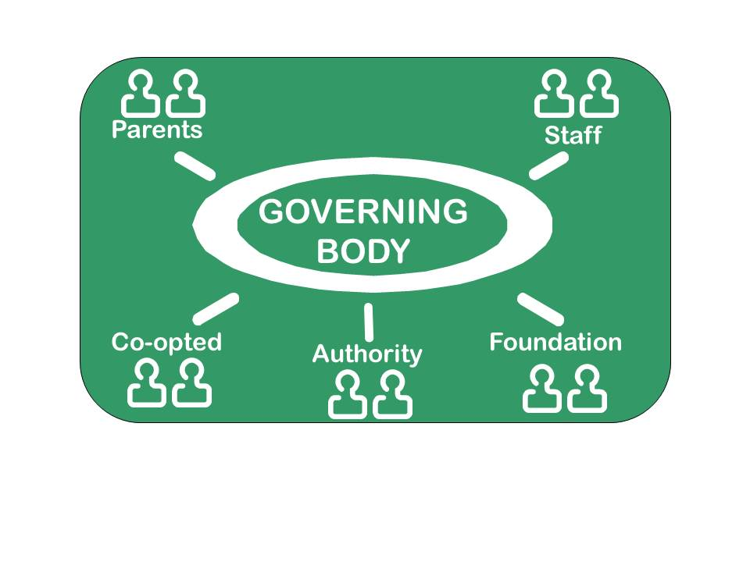
Parent Governors: parents of a child at the school and elected by the parents. Contact the school directly for details of any vacancies
Staff Governors: the Headteacher plus members of the teaching or support staff elected by other staff
Co-opted Governors: appointed by the governing body, bringing specific skills or links with the community. Contact the school directly for details of any vacancies
Authority Governors: recommended by the Local Authority and appointed by the governing body. Contact Governor Services for details of any vacancies.
Foundation Governors and Foundation Trust Governors: appointed to faith or trust schools, by the Diocese, Trust Board or other partner organisations. Contact the school directly for details of any vacancies.

You could be a governor if…………….

- You are aged 18 or over
- You are interested in education and would like to support a school
- You want to contribute to your community
- You can spare about 6-8 hours per month
- You can work as part of a team
- You are willing to take on responsibility



There isn’t an upper age limit and you don’t have to have prior knowledge, experience or specific qualifications

Governors come from all walks of life; what they share is the difference they make to the lives of Newcastle’s children

Contact the Governor Services Team
Please contact the team if you have any questions about becoming a school governor, or if you require any further information about the training and support we provide.

Phone:
Contact the team on 0191 277 3711.

Email:
governorservices@newcastle.gov.uk

Write:
Governor Services
Room 136
Civic Centre
Newcastle upon Tyne
NE1 8PU

