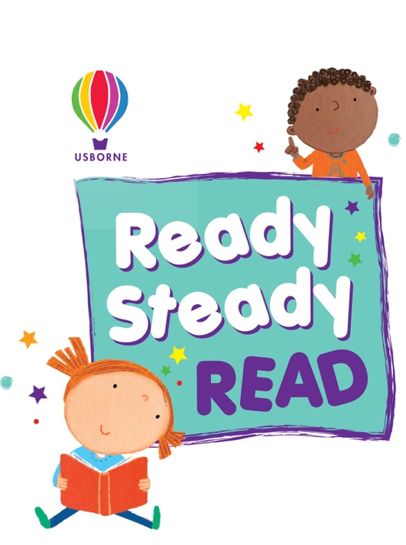

Dear Parent/Guardian,

To celebrate and encourage a lifelong love of reading at home and school, we will be running a sponsored read between 26th and 31st October 2020.

The project is being organised in conjunction with our Usborne Organiser, Vikki MacDonald and all the money raised will go towards brand new books for our school.

In addition to the sponsorship money, Usborne also will donate up to 60% of the total raised in EXTRA FREE BOOKS to the school. So for every £600 raised, we will get an extra £360 in FREE Usborne books!

Please help us to enhance our reading resources for pupils by encouraging your child to spend a small amount of time each day either reading to themselves, to others, or being read to. They can read anything with words (for example comics, recipes, magazines) for as long or as little as they like.

Should you wish to support our sponsored read, please find enclosed a sponsorship form for your child. A reading log, to record the minutes they have spent reading, will be given to them in class.

After the sponsored read, please send all the sponsorship money via the PayPal link below, by 9th November 2020.

https://paypal.me/pools/c/8tuTZpixBU

Please support our sponsored read so that your child has more books to read, share and enjoy.

For more information, contact Vikki MacDonald:
07539460444 or via email vikki.usbornebooks@outlook.com

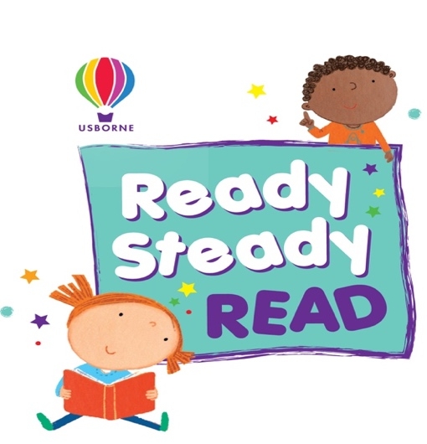

Sponsorship Form

Lemington Riverside Primary School

Pupil name: ………………………………… Class: …………………….…

Name | Address and contact details | Sponsorship  (per minute or total donation) | Amount collected | Total

Total Amount: ……………………

Please return sponsorship money via the link below by 9th November 2029 –
https://paypal.me/pools/c/8tuTZpixBU

For more information, contact Vikki MacDonald:
07539460444 or via email vikki.usbornebooks@outlook.com

Reading Log

Lemington Riverside Primary School

Pupil name: ………………………… Class: ………………….…

Day | Minutes Read | Total
Monday
Tuesday
Wednesday
Thursday
Friday
Saturday
Sunday

Total minutes read ……………………

For more information, contact Vikki MacDonald:
07539460444 or via email vikki.usbornebooks@outlook.com

