Learning Project WEEK 2- The area you live in
Age Range: EYFS
Weekly Maths Tasks (Aim to do 1 per day) | Weekly Reading Tasks (Aim to do 1 per day)
- Watch a Numberblocks clip each day at: BBC or CBeebies. Use this guide here to give you ideas on what to do with your children whilst watching an episode.  - Working on Numbots - your child will have an individual login to access this.  - Play the Numberblocks adding game.  - Practise counting backwards from 20. This can be done through playing hide and seek, singing number songs, chanting, board games etc.  - Write out the digits 0 - 9.  - Use the ‘Tens Frames’ or ‘Five Frames’ on this game and practise recognising amounts. This can also be done by reading a dice when playing board games, playing with cards, identifying how many food items on the plate etc.  - Sing Number songs to practice counting, reciting numbers in order, one more, one less using number songs: Five Little Ducks, Five Little Men, Ten Green Bottles.  - Look for the numbers on the doors of houses. Do the numbers get bigger or smaller as you go up and down the street? | - Read a variety of books at home. Favourites can be repeated. Hearing the patterns of language in a story will support your child’s language development.  - Reception age children: Children to read to parents daily. Visit Oxford Owl for free eBooks that link to your child’s book band. You can create a free account.  Complete the linked Play activities for each book.  - With your child, look in magazines, newspapers and books for the tricky words they are currently learning. They could use a highlighter to highlight in magazines and newspapers.  - Read the story Hansel and Gretel (or watch on youtube)- What makes the house appealing to the children?  - Read the story of The Three Little Pigs (or watch on youtube)- Discuss the choices the little pigs make about the materials they use to build their houses. Can children figure out the material their own house is made from?
Weekly Phonics Tasks (Aim to do 1 per day) | Weekly Writing Tasks (Aim to do 1 per day)
- Sing Nursery Rhymes and songs together. Add in actions and change the words. Can children think of different rhyming words to add in? Repeat old favourites and learn new rhymes. You can find an A-Z of Nursery Rhymes here.  - Daily phonics - Practice the sounds your child is working on and blend words. This can be oral blending (e.g. spoken out loud c-a-t) or written if appropriate. Interactive games.  - Send your child on a sound hunt around the house. Can they find and record all of the items that make sounds? (e.g. hairdryer, TV, fridge, microwave, phone) | - Design your dream house. What rooms would you like to have in your house? Encourage children to be as imaginative as they can (e.g. a cinema room, a chocolate room). Can they label their house using their phonics knowledge?  - Practice name writing. Can they write their first name? Middle name? Surname?  - Practice forming the letters of the alphabet. Follow your school’s script.  - Ask your child to write out the tricky words they are working on at the moment on pieces of paper and turn them into a pairs game.
Learning Project - to be done throughout the week
The project this week aims to provide opportunities for your child to learn more about the area in which they live. Learning may focus on your local area, famous people, key landmarks and links to your city.

- The rooms in my house-
  - Support your child to create a map or cross section of their home. Can they name all of the rooms? An adult could hide an object in a room and mark where it is on the child’s map. Can they use their map to find the hidden object? Label each room using phonics knowledge.
  - Gather an object from each room and challenge your child to return them to the appropriate room e.g. toothbrush from the bathroom, teddy from their bedroom.
  - Hide objects around the room and describe where it is e.g. “it’s under something red” Can your child hide an object and describe where it is for you to find?
- Go on a numeral hunt-
  - Search for numerals around the house (clocks, books, house numbers, car registrations, oven, washing machine). Can they record the numerals on paper?
- Find your house on google maps-
  - Explore using google maps to look at your house from above and on street view. Use the arrows to move up and down the road and around your area. Can they find key places e.g. the corner shop, their school, grandparents houses.
  - Search for a house in a different part of the world and discuss how it is similar or different to your own. You could use places children have visited on holiday or search places that are significantly different.
- Junk model your house-
  - Using old packaging (shoe box, cereal box etc.) support your child to make a model of your house. Can they count how many windows there are and stick on the right amount? Can they write their house number on the front?
  - Junk model your dream house. Use materials from around your house to decorate e.g. old wallpaper, fabric, wool.
- Go on a shape hunt-
  - Set your child a shape finding challenge around the house. Ask: Can you find a triangle/ square/ rectangle/ circle in this room? How many can you find? Can you draw all of the circles on one piece of paper, triangles on another etc.
- Use construction blocks to build your house-
  - Using lego, duplo, wooden blocks make a model of your house. Can they add in the rooms and doors in the right places? Write labels to match each room on pieces of paper.
  - Build your dream house out of construction blocks.
- Create a furniture collage-
  - Using old magazines and catalogues support your child to cut out and stick or sort objects into the room they would belong in. Support your child to use the correct scissor grip using this guide.
- Exploring with your senses-
  - Gather a collection of household objects e.g. fork, cup, toothbrush, teddy bear, book and show your child. Use a scarf/ material as a blindfold and pass your child one of the objects. Can they figure out what it is through touch alone? Give clues if they are struggling. Swap roles and ask your child to give you an object to figure out.
  - Explore the textures around your house. Can children find something rough, smooth, bumpy.They could take a wax rubbing of each texture (Lay a piece of paper over the top and rub over with the side of a crayon). You could continue this into the garden.
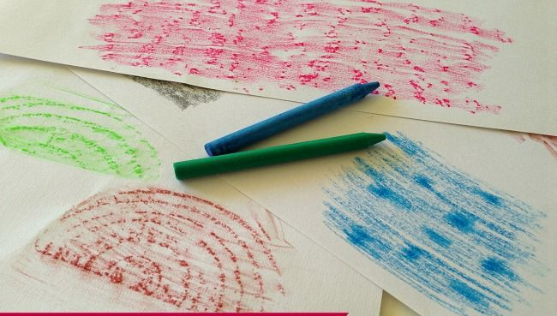
Additional learning resources parents may wish to engage with
Classroom Secrets Learning Packs - These packs are split into different year groups and include activities linked to reading, writing, maths and practical ideas you can do around the home.
Twinkl - to access these resources click on the link and sign up using your own email address and creating your own password. Use the offer code UKTWINKLHELPS.
Headteacherchat - This is a blog that has links to various learning platforms. Lots of these are free to access.
#TheLearningProjects

